skimage去除空洞和去除小物体
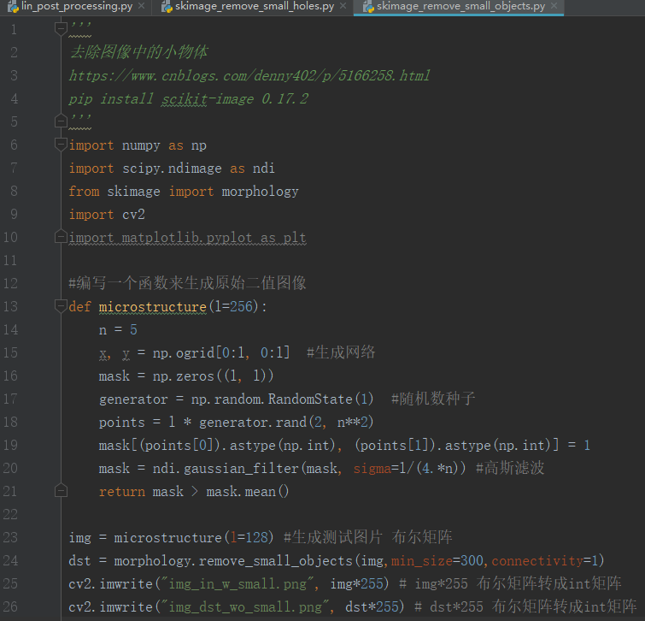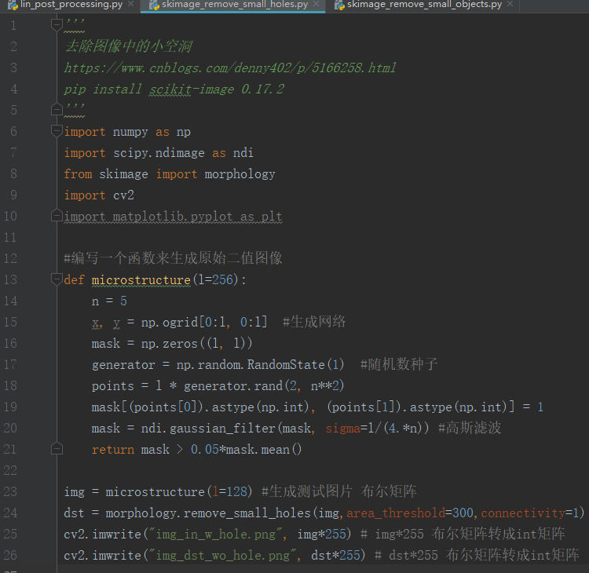


lin_post_processing.py
对预测结果航拍大图进行去除小空洞和小物体
并进行可视化对比，去除和不去除的区别
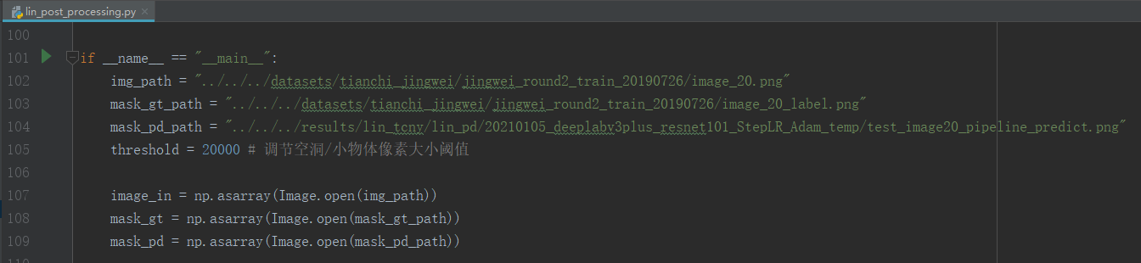
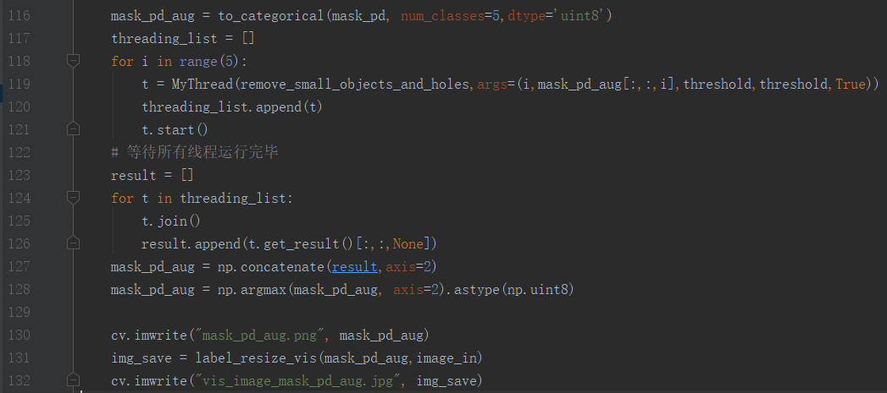
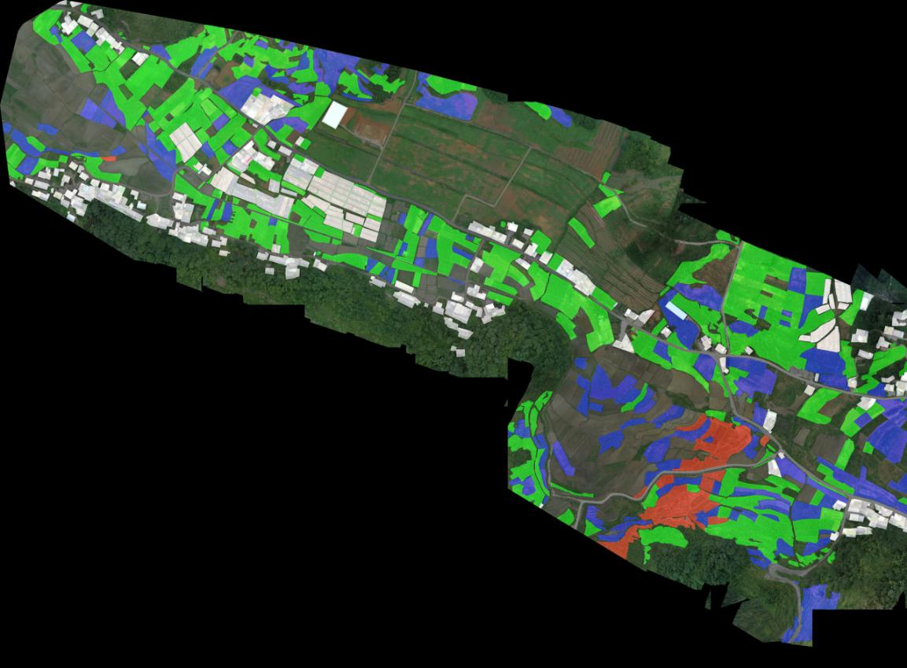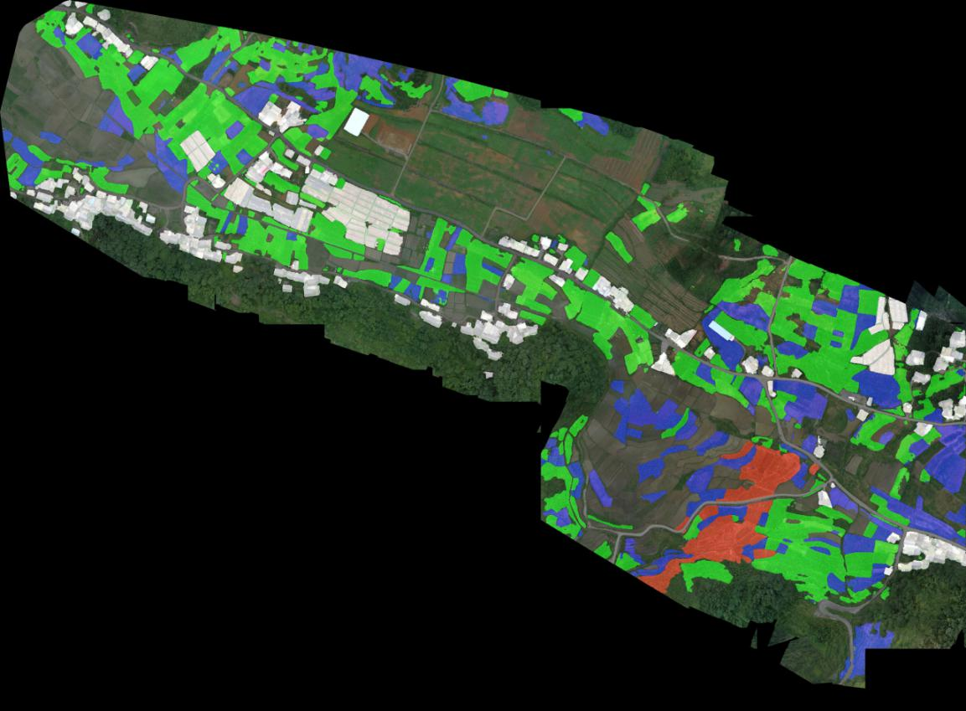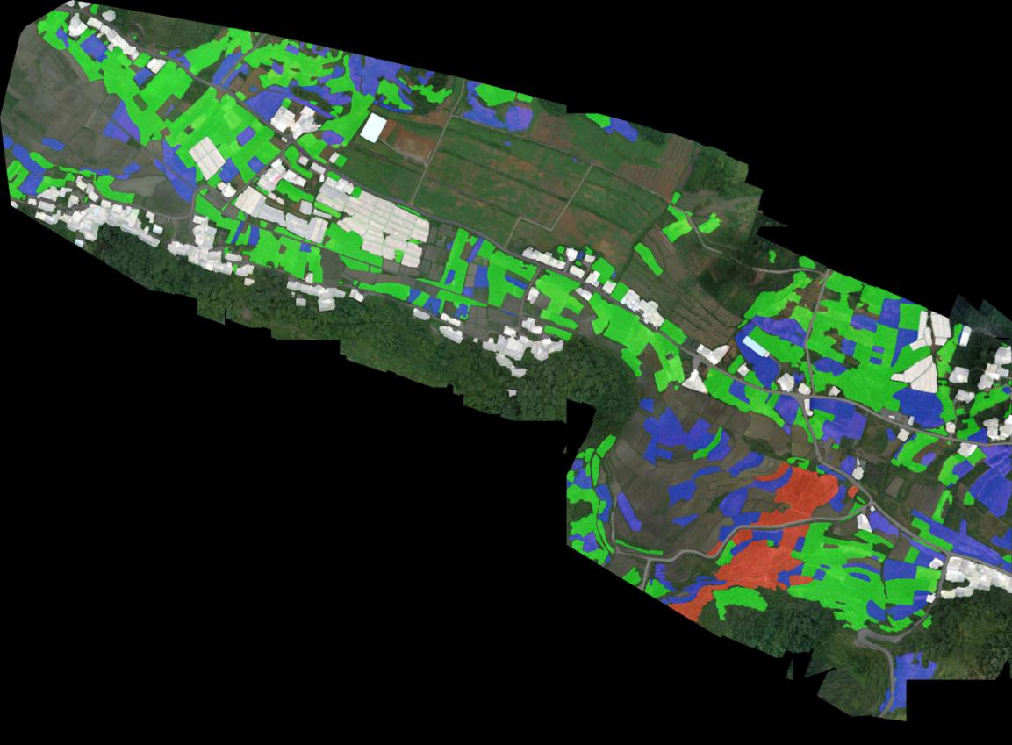
vis_image_mask_gt vis_image_mask_pd vis_image_mask_pd_aug
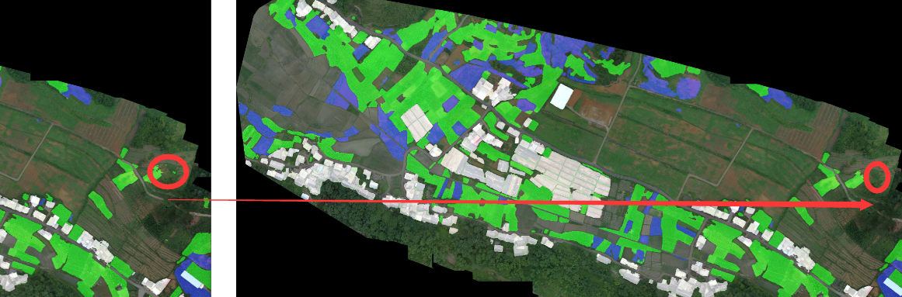

参考：
https://www.cnblogs.com/denny402/p/5166258.html
样例代码
https://blog.csdn.net/qq_33329896/article/details/85007198
函数remove_small_objects()解析
https://blog.csdn.net/u013044310/article/details/80585647
python模仿remove_small_objects（)函数保留图片中连通域最大的区域
https://jianzhuwang.blog.csdn.net/article/details/106999894
remove_small_objects移除面积小的连通区域无效

